How to Install Offline Maps in Tablet Command

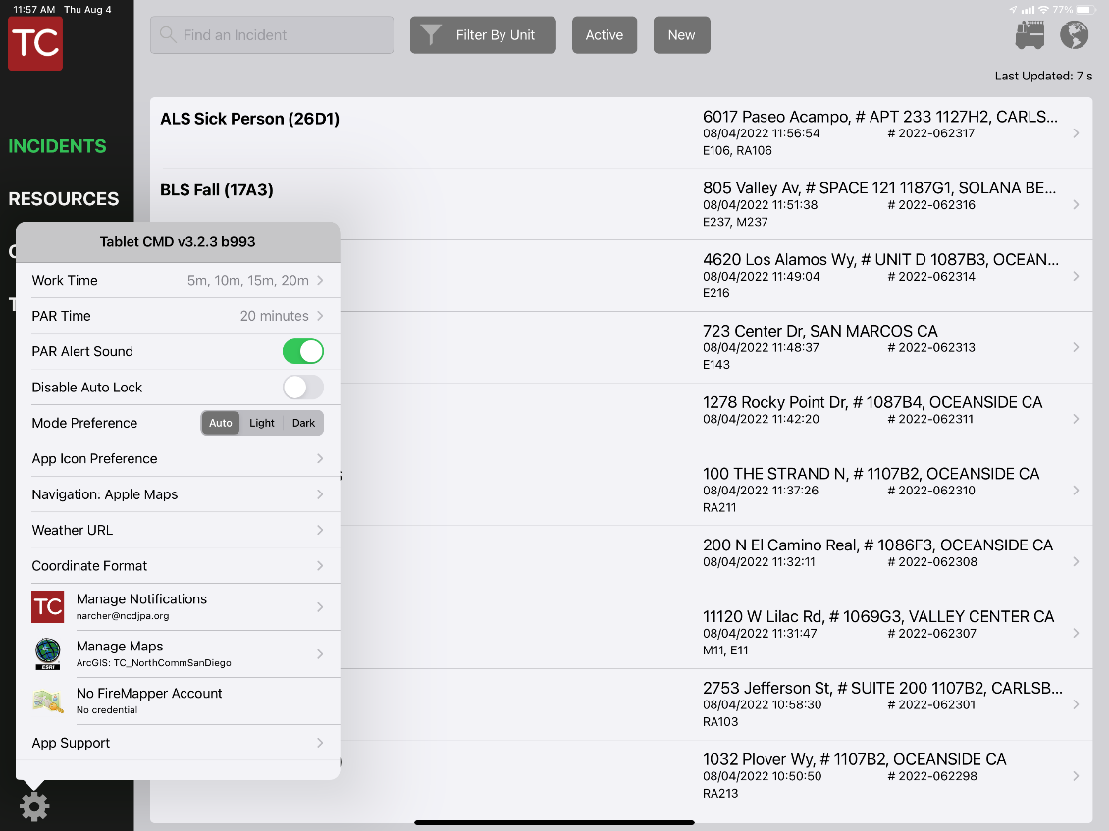

2. Select Manage Maps

1. Select the gear in the bottom right corner

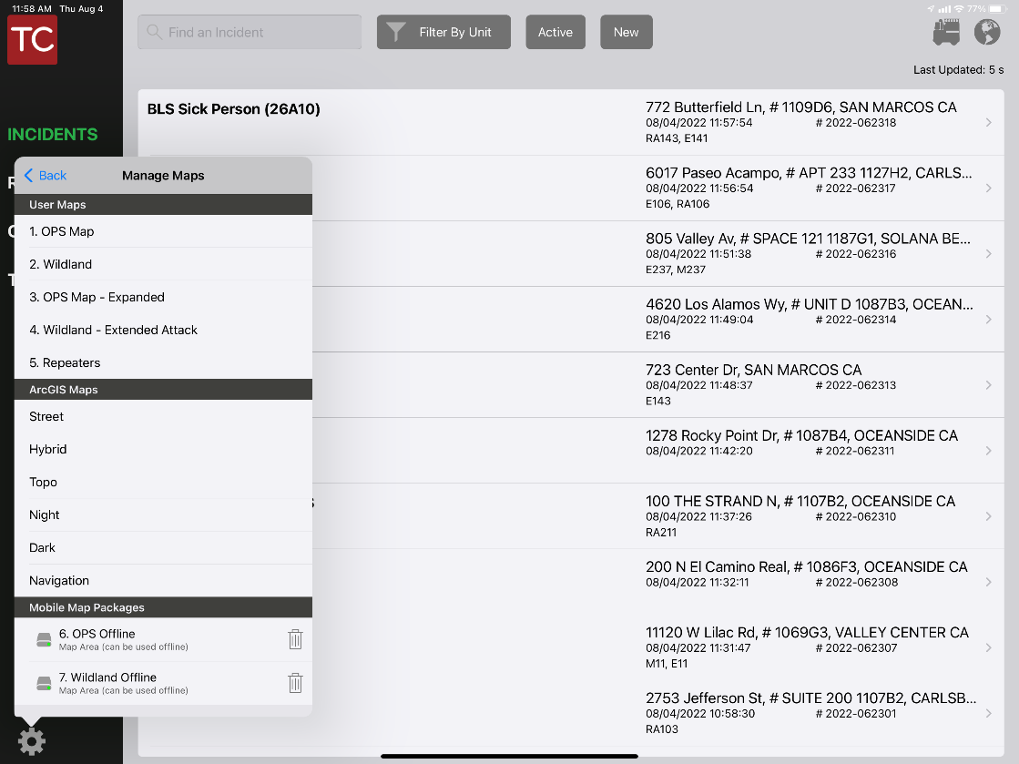

Hit the cloud icon to the right of each map name to download the offline map. Once it is downloaded the cloud will be replaced by a trash can. Hitting the trash can will delete the map from your device.

Hit the Manage Maps button then the refresh button next to the trash can to download the update.

If there is an update to an offline map you will get a notification here.

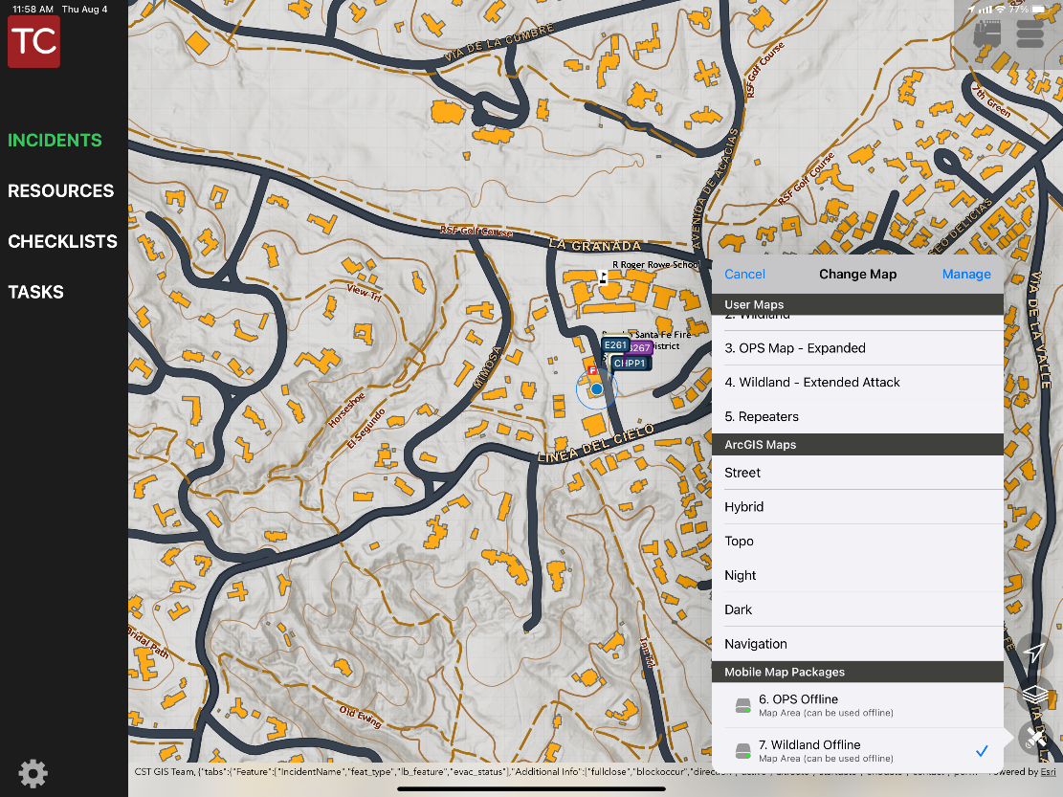

Once downloaded, you can select the offline map by hitting the satelite icon in the bottom right. The offline maps are at the bottom of the list under Mobile Map Packages.

Layers can be turned off and on by selecting the 3 square icon. Any layer in the offline maps that ends in (Online) requires an internet signal to display the information on the map.