Select a Wildland Preplan PDF

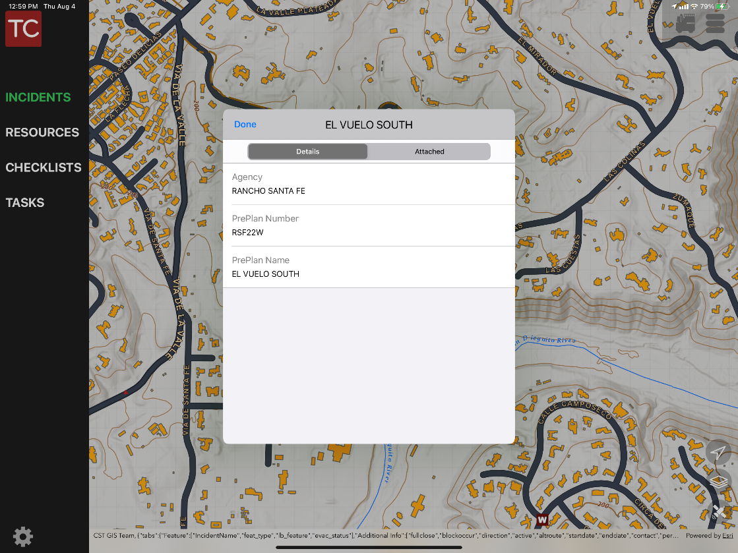

1. Tap a W icon on the map

2. A pop up will appear with the preplan information

1. Select the Attached button

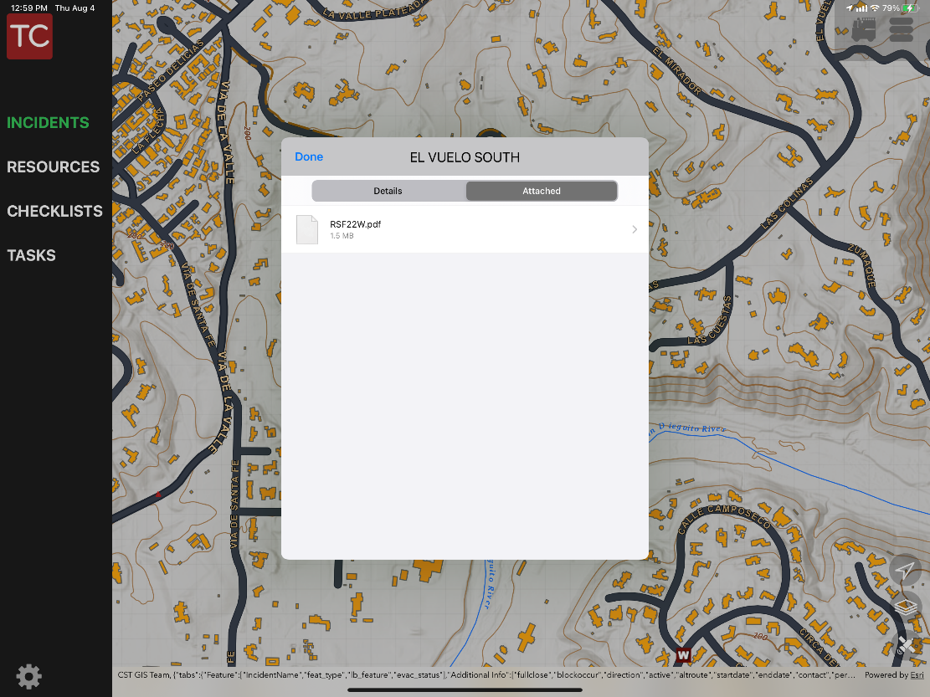

2. Select the pdf

The PDF will open on the screen. The PDFs can be opened without internet connection if using the 7. Wildlands Offline map. Hit done to return to Tablet Command.

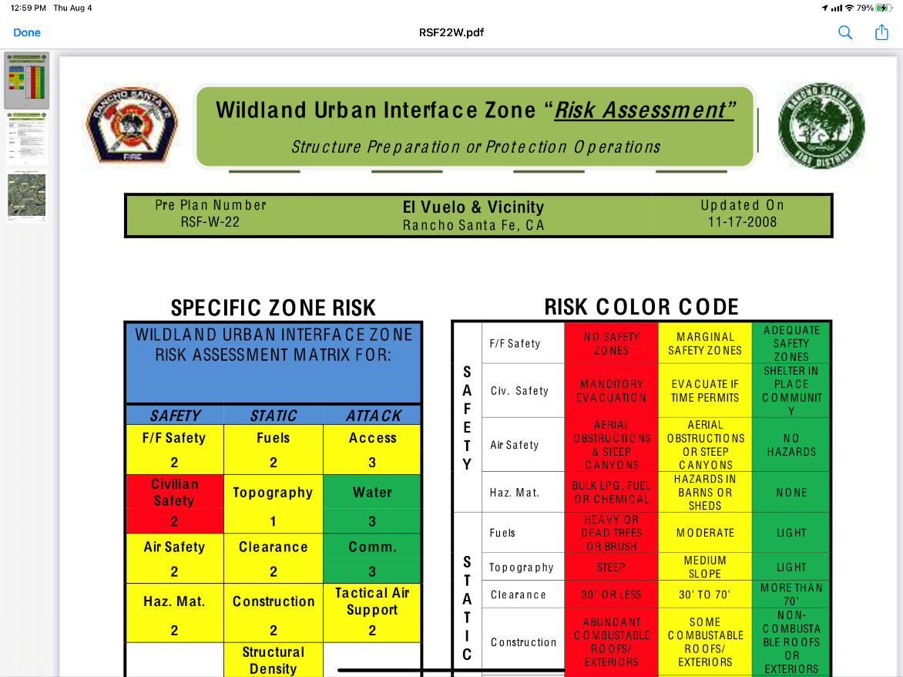

Once downloaded, you can select the offline map by hitting the satelite icon in the bottom right. The offline maps are at the bottom of the list under Mobile Map Packages.

Layers can be turned off and on by selecting the 3 square icon. Any layer in the offline maps that ends in (Online) requires an internet signal to display the information on the map.